Clayton County Conservation Board

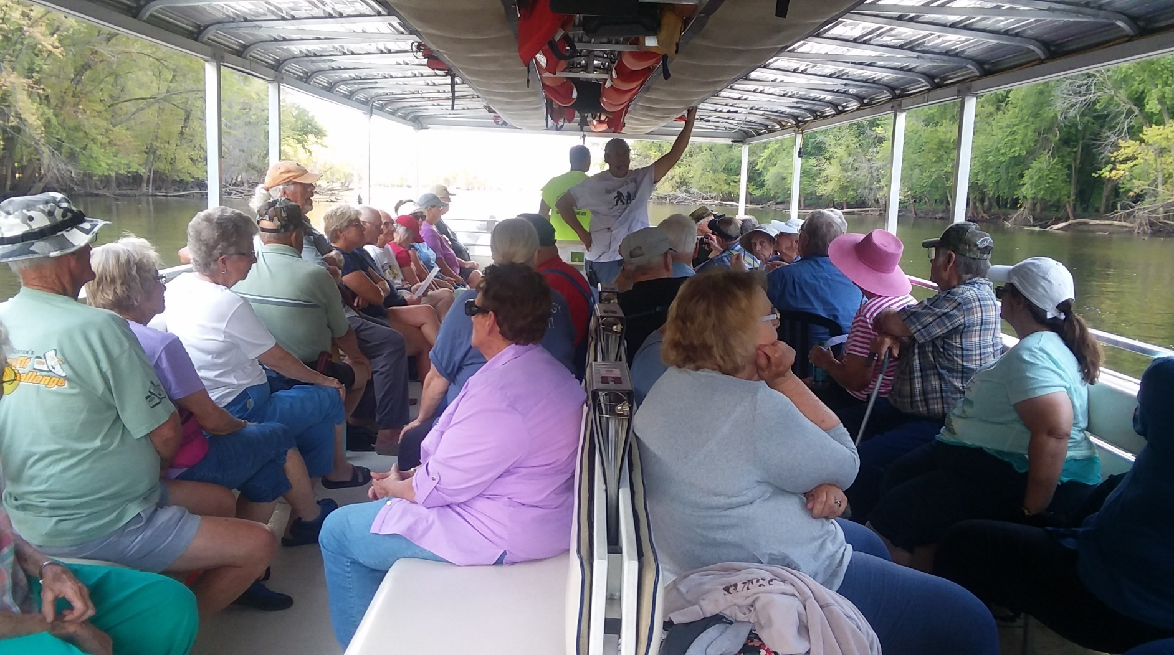

***“A Mississippi River Adventure on the Maiden Voyage”***

**“Mississippi River Adventure”**

**Tuesday, August 15th**

**Shuttle leaves Osborne Park at 11:15 a.m.**

Join O.W.L.S. for a fun afternoon on the Mississippi River as we charter the Maiden Voyage. Captain Robert Varva is an excellent skipper, adventure leader, and storyteller. Learn about early explorers, commercial fishing, and clamming while watching wildlife up close.

**The trip will include a Mississippi fish fry.**

**Registration Required - Phone: 245-1516**

**www.claytoncountyconservation.org**