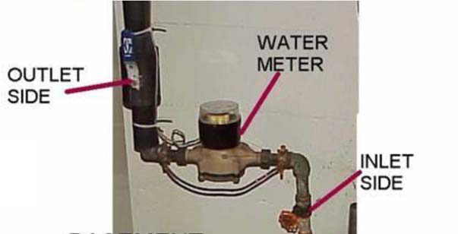
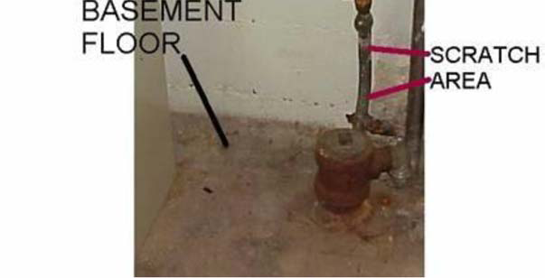

How to Determine the Material of Your Service Line
1) find your water meter. It is usually on the lowest floor of the building. Most often water meters are found in the basement but can be in a mechanical room or crawlspace.

2) follow the line from the meter to the outer wall.

3) Do a scratch test or a magnet test of the pipe in this area – between the meter and the outer wall.

4) Service line material can be galvanized steel, lead, or copper. Newer construction may have PEX (plastic).
- Lead lines will be shiny when scratched with a quarter. A magnet WILL NOT stick to the pipe.
- Galvanized steel lines will be dull gray in color when scratched with a quarter. A magnet WILL stick to the pipe.
- Copper pipes will be shiny and bronze in color when scratched with a quarter. A magnet WILL NOT stick to a copper pipe.

